**NAMA : KRISANTUS ISAK EVANDRI MODU**

**NIM : 215410023**

**KELAS : INFORMATIKA 1**

**PRAKTIKUM PEMROGRAMAN BERBASIS MOBILE**

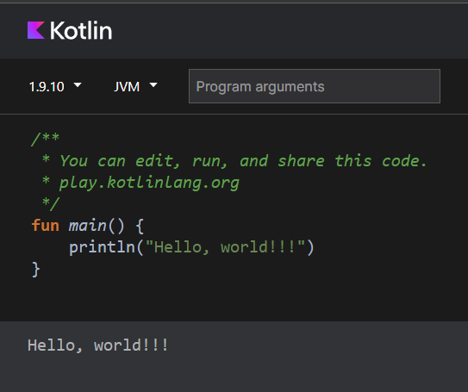

LATIHAN

Tes kedua

